The Bradford on Avon & Melksham Health Partnership Number of Responses: **504**

**Patient Questionnaire Results February 2014**

**Section 1 - Methods of communication**

**Which method of communication do you most often use to get in touch with the surgery?**

By telephone **77% = Improvement on last**

By visiting the surgery **15% years results**

By post **0%**

Other (please state below) **3% = More work still to be**

No response **5% done**



**= Stayed the same**

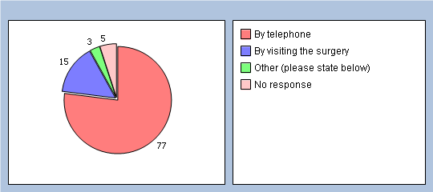

**Are you aware the practice provides the following methods of communication?**

***Telephoning/texting the 24 hour appointment cancellation line (01225 860025)***

Yes **72%**

No **24%**

No response **4%**

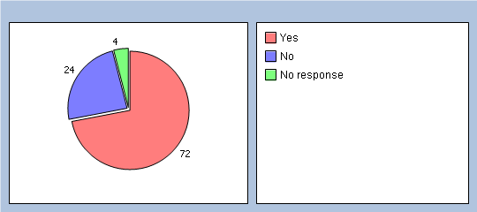

***Practice website (www.boamhp.co.uk)***

Yes **62%**

No **40%**

No response **8%**

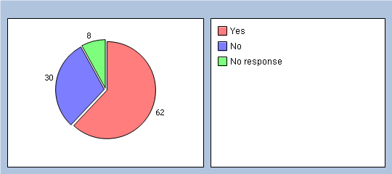

***Book & cancel appointments on-line via the practice website***

Yes **54%**

No **39%**

No response **7%**

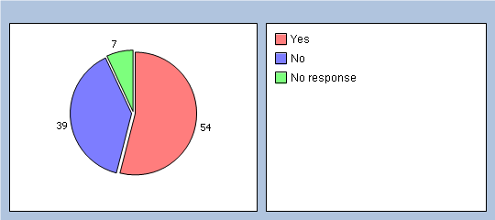

***Text message reminders to your mobile phone the day before your appointment***

Yes **65%**

No **29%**

No response **6%**

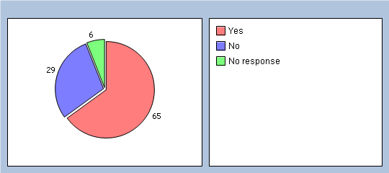

***Ordering repeat medication on-line via the practice website***

Yes **49%**

No **45%**

No response **6%**

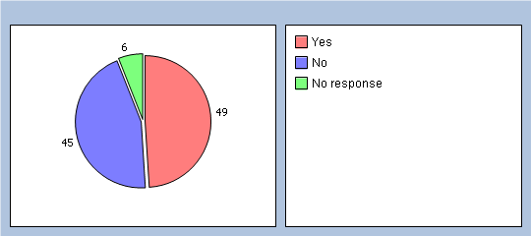

***Updating your contact details on-line via the practice website***

Yes **46%**

No **45%**

No response **9%**

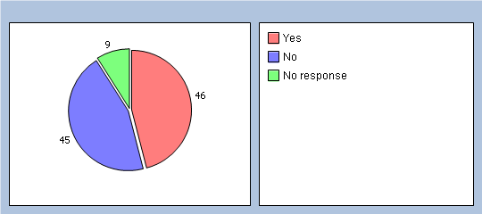

***The 'Patient Voice' e-mail group boamhp.patientvoice@nhs.net - for patients who would like to provide the practice with opinions/feedback about services at the practice***

Yes **34%**

No **58%**

No response **8%**

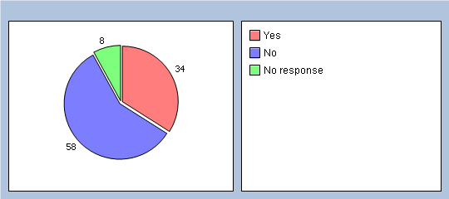

***The quarterly Patient Participation Group Meetings - for patients to get involved and learn more about the practice***

Yes **46%**

No **46%**

No response **8%**

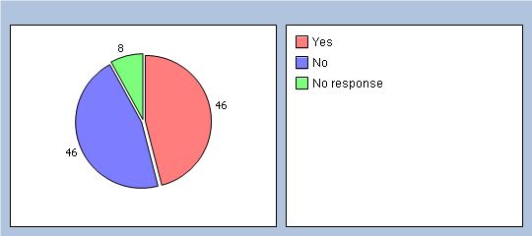

***Practice Newsletter in patient waiting rooms & via the practice website***

Yes **61%**

No **32%**

No response **7%**

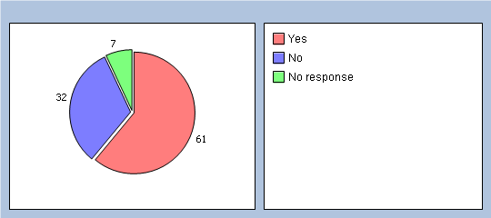

***Feedback form, via the home screen of the practice website***

Yes **38%**

No **54%**

No response **8%**

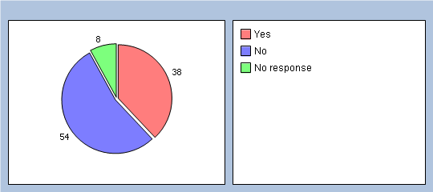

***Suggestion boxes in waiting room at all practice sites***

Yes **71%**

No **23%**

No response **6%**

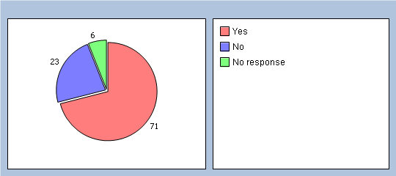

**Section 2 - Ease of communication**

**How easy is it for you to contact the practice by telephone?**

Very easy **33%**

Fairly easy **34%**

Sometimes difficult **20%**

Very difficult **5%**

Don't know **1%**

No response **7%**

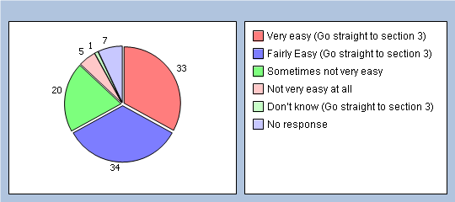

**If you have selected 'Sometimes difficult' or 'Very difficult' - what time of day do you find is most difficult?**

8:30am-10:30am **30%**

11am-1pm **2%**

1pm-2pm (lunchtime) **0%**

2pm-6pm **0%**

Don't know **5%**

No response **63%**

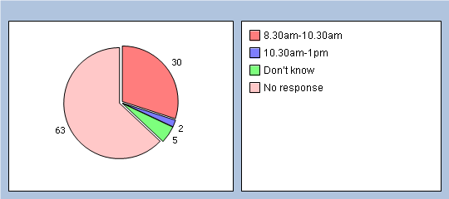

**And if you are a patient of The Health Centre, BOA, which department do you find less easy to contact?**

Patient Liaison/Home Visits **1%**

Appointments Desk **21%**

Results Service **0%**

General Enquiries **0%**

Don't know **4%**

No response **74%**

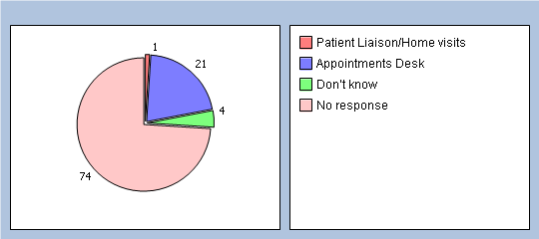

**Section 3 - Convenience**

**In addition to appointments (and telephone consultations) offered during the day, the practice also offers some appointments (and telephone consultations) with the Doctors outside normal working hours (before 8am and after 6:30pm).**

**This is classed as Extended Hours - were you aware of this service?**

Yes **52%**

No **46%**

No response **2%**

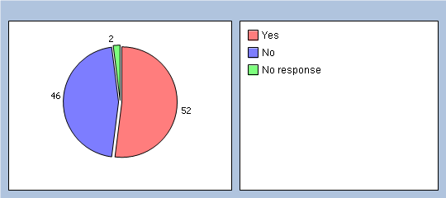

### ****Have you used this service before?****

Yes  32%

No  63%

No response  5%

**If YES, how do you rate this service?**

Very good **21%**

Good **12%**

Fair **1%**

Poor **0%**

Very Poor **0%**

Don't know **5%**

No response **61%**

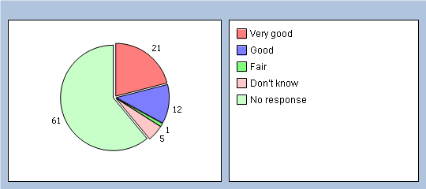

**If NO, would you benefit from this service?**

Yes **41%**

No **18%**

No response **41%**

**Is convenience of appointment times important to you?**

Yes, I work full time so it is difficult to leave work to attend appointments **32%**

Yes, I am a carer so need to arrange appointments around the person I care for **7%**

Yes, I need to organise things around child care or around school hours **10%**

No, convenience is not important to me **7%**

No, I can attend the surgery anytime **26%**

Other (please state) **5%**

No response **13%**

**Section 4 - Appointment availability**

**How long did you wait to obtain your most recent appointment with a Doctor at the practice?**

One day **20%**

2 days **10%**

3 - 4 days **20%**

5 days **8%**

6 - 7 days **17%**

8 days or longer **16%**

No response 9**%**

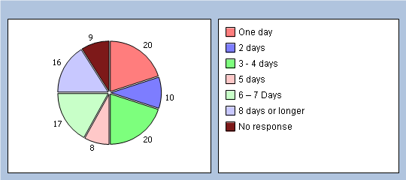

**How do you rate this?**

Excellent **20%**

Very good **21%**

Good **14%**

Fair **21%**

Poor **11%**

Very poor **2%**

No response **11%**

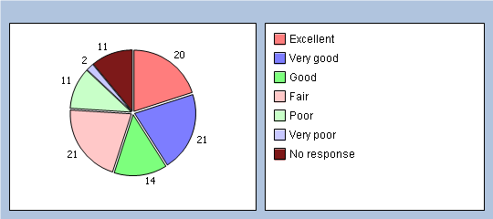

**Is there a particular GP you usually prefer to see or speak to?**

Yes **65%**

No **23%**

No response **12%**

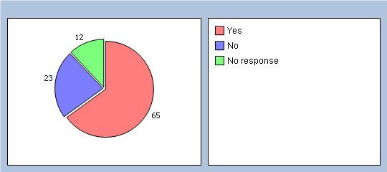

**How often do you see or speak to the GP your prefer?**

Always **19%**

A lot of the time **30%**

Some of the time **22%**

Never **2%**

I don't mind who I see **13%**

No response **14%**

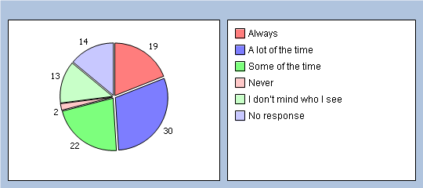

### ****Did you know that you are able to attend any of the Practice sites to see a GP, which may mean you are sometimes able to see the GP you prefer more easily?****

Yes 61%

No 29%

No response 10%

### ****How do you rate the overall service provided by the Doctors?****

Excellent 29%

Very good 39%

Good 15%

Fair 5%

Poor 1%

Very poor 0%

No response 11%

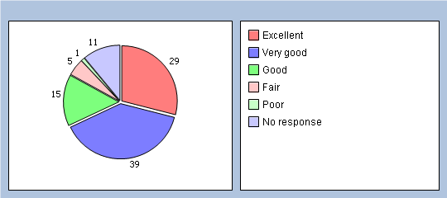

### ****Section 5: Appointment Availability - Nurse****

### ****How long did you wait (number of working days) to obtain your most recent appointment with the Nurse?****

One day 25%

2 days 18%

3 - 4 days 19%

5 days 8%

6 – 7 Days 6%

8 days or longer 7%

No response 17%

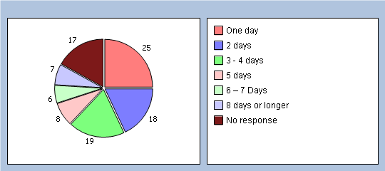

### ****How do you rate this?****

Excellent 28%

Very good 27%

Good 15%

Fair 8%

Poor 3%

Very poor 0%

No response 19%

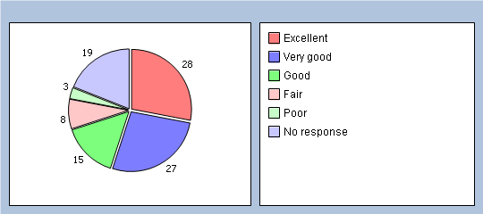

### ****What did you come to see the Nurse for?****

Blood test 39%

Blood Pressure test 4%

Dressing 3%

ECG 0%

Cervical Smear 3%

Chronic Disease Clinic (Diabetes/Asthma/Coronary Heart Disease, etc) 4%

Same day urgent appointment with an Emergency Nurse13%

Other, please state: 9%

No response 25%

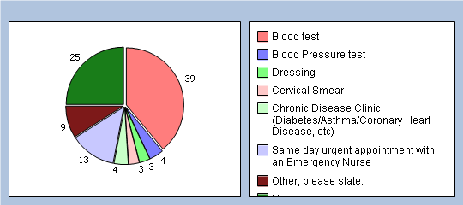

### ****Have you recently attended an urgent (same day) appointment with the Emergency Nurse?****

Yes 32%

No 54%

Don’t know 1%

No response 13%

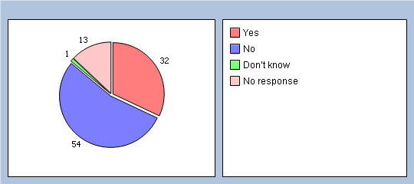

### ****How do you rate this service?****

Excellent  26%

Very good  14%

Good  6%

Fair  2%

Poor  0%

Very poor  0%

No response  52%

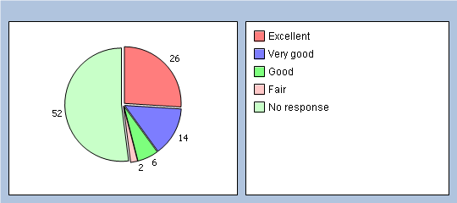

### ****How do you rate the overall service provided by the Nursing Team?****

Excellent  42%

Very good  22%

Good  10%

Fair  1%

Poor  0%

Very poor  0%

No response  25%

**Section 6 - Your details**

***It will help us understand your answers if you could tell us a little about yourself.***

**Which surgery do you usually attend?**

The Bradford on Avon Health Centre 44%

Winsley Health Centre 6%

St Damian's Surgery, Melksham 42%

No response 8%

**Are you?**

Male **32%**

Female **59%**

No response **9%**

**How old are you?**

Under 16 **2%**

16 to 44 **24%**

45 to 64 **34%**

65 to 74 **19%**

75 and over **14%**

No response **7%**

**Do you have a long-standing health condition?**

Yes **50%**

No **35%**

Don't know **5%**

No response **10%**

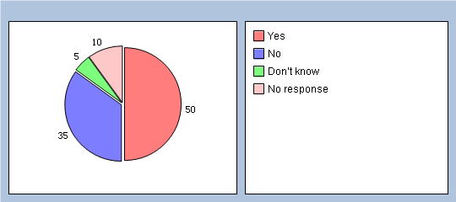

**Which of the following best describes you?**

Employed (full or part time including self employed) **41%**

Unemployed/looking for work **1%**

At school or in full time education **1%**

Unable to work due to long term sickness **5%**

Looking after your home/family **5%**

Retired from paid work **31%**

A full time carer **4%**

Other (please state) **1%** & No response **11%**

**What is your ethnic group?**

White **88%**

Black or Black British **1%**

Asian or Asian British **0%**

Mixed **0%**

Chinese **0%**

Other ethnic group (please state below) **0%**

Would prefer not to say **0%**

No response **11%**

**Section 6 - Any other comments**

Of the 504 patient surveys completed, there were 148 written comments at the end of the questionnaire. Of these comments, 89 were positive and 59 were providing the practice with constructive comments:



The 89 positive comments can be split into two sections:



Of the 89 positive comments here are some examples:

*“Everybody is so warm and friendly - Helpful too.”*

*“BOA Health Centre is an excellent surgery. The receptionists are very friendly and helpful. I have had no difficulty in seeing my doctor, and I have been more than satisfied with the friendly and efficient nurses I have had appointments with”*

*“I find St Damian’s surgery team are very good. They are true professionals. Well done. Keep up the good work.”*

*““I find this surgery excellent, receptionists and all the staff most helpful, especially as I am not in good health and am a carer for my husband who is disabled.”*

***“****The surgery and dispensary at Winsley are great….the Doctor is very responsive and we feel very supported. Thank you”*

*“Very friendly always listen to your problems, take their time when you need to talk longer than your appt, don’t feel rushed”*

The 59 constructive comments can be broken down into various categories:



In summary, the majority of the comments were based around the availability of appointments and the lack of continuity (34%). 23% of patients mentioned the telephone system.

Of the 59 comments, here are some examples:

**Telephone System – “**it is difficult to contact the practice by phone as lines always busy, once the phones answered receptionists are helpful”

**Prescription Service – “**I find not being able to make a request for repeat script over the phone very inconvenient as I work long hours, all over the uk!”

**Admin/Reception Staff – “**some reception staff seem to think it's ok to continue to stare at their computer screen, answer the phone, take in deliveries, prepare the post etc all as a priority over dealing with those waiting at the desk. It's not.”

**Appointment Availability/Continuity –** My experience as a new patient has generally been very positive. My only concern is the difficulty in getting an appointment to see my Dr in less than 6 days.

**Doctors –**“ The comment made by some G.P's (not all) "eat less, drink less, exercise more" would be more appropriate is they actually knew you.

**Practice Merger –** “It’s since the merger, just made the whole practice too big ( I’ve never seen an advert to Bigger is Better!!! Perhaps more services, but not as personal”

**Waiting Room –** “Usually excellent but having run all the way here to be on time it is very annoying to then wait 30 mins or more to be seen - and not always an apology”

**Other –** Make a small fee for missed appointments i.e. £5

**Section 7 – Proposed Actions based on Survey results**

|  |  |  |  |
| --- | --- | --- | --- |
|  | **Proposed action** | **Details** | **Implementation** |
| 1 | Continue publicity around alternative methods of communication | Although the survey results this year (and last year) show an improvement, more awareness is required | On-going |
| 2 | Improve ability for patients to contact the appointment desk, at The Bradford on Avon Health Centre, early morning. | Although over the last two years (in response to the results of the patient survey’s) extra staff have been made available to answer the appointments line in the morning. However, the survey results for this year shows this still hasn’t been enough!  The Results line is currently open 8.30-5.30 each week day.  Propose the opening times for the Results line is changed to 11.00-5.30 each week day. This will allow a member of staff to provide early morning support on the appointments line at BOAHC instead.  Publicity of this change will be essential. | 1st June 2014 |
| 3 | Last year the Doctors developed Self Help Information for Minor Illness which was put on the practice website.  Propose for this year to publicise this information more widely by trying to locate funding to have the information in a booklet format for patients to pick up.  Which in turn may reduce telephone calls to the appointment line for general advice. | The booklet would help patients know what to do, in the first instance, when they have a minor illness (flu, diarrhoea & vomiting, sore throat, etc). | 1st October 2014 |

|  |  |  |  |
| --- | --- | --- | --- |
| 4 | Continuity with the same Doctor is important for on-going conditions.  Create a new appointment information leaflet to explain how the appointment system works and what different routes of communication the patient has to get in touch with the Doctor. | Survey results show 65% of patients would prefer to see their ‘usual’ GP. 19% of patients felt they were able to ‘always’ see their usual GP with 52% saying they were able to see their usual GP ‘a lot’ or ‘some of the time’. 50% of patients waited 1-4 days for their most recent GP appointment. | 1st October 2014 |
| 5 | At the bottom of the questionnaire patients were asked to make ‘any further comments’. There were a number of comments regarding the service provided by the Admin/Reception team & the length of wait in the waiting room.  Propose that a small survey is conducted to capture more information about these areas. | In response to the results of last years survey (2013) – to reduce the length of time in the waiting room – the Doctors put ‘catch up slots’ in each routine GP surgery.  New survey to be available during September 2014 in the waiting area and on the practice website for patients to complete.  Results of survey (and action plan) to be publicised on website and in waiting rooms during November. | 1st September 2014 |
| 6 | In the ‘comments’ section it was also mentioned how large the practice has become and concerns have been raised that the Practice may have lost some of its ‘personal’ service.  Propose the following measures are implemented immediately:   * Staff to say their name when answering the telephone * Staff to ask patients if there is a particular nurse they would like to see (to aid continuity) * Arrange a meeting with the Practice staff (including Doctors & Nurses) ‘in house’ to ask for their ideas of how the service could be made ‘more personal’. * Ensure a question relating to‘personal service’ is put on the patient survey for next year so that we may measure this further. | In response to the results of last year’s survey (2013) - to maintain & improve the ‘personal touch’ at the practice – we have ensured continuity of staff at reception, so that patients see familiar faces. | On-going |

*March 2014*