Hypnotherapy
Lindsay Rogers
BDS, HPD, DipCAH, DipCBT, PNLP
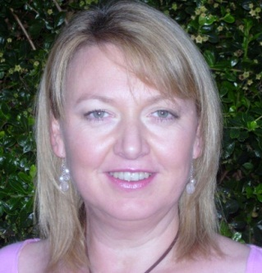

I am a qualified Clinical Hypnotherapist registered with the National Council for Hypnotherapy and UK (CHO). I have a diploma in Cognitive Behavioural Therapy (CBT) and I am a Certified Practitioner of Neuro-linguistic Programming (NLP).
Hypnotherapy is a safe, natural and effective therapy. It works with your subconscious mind to identify thoughts, emotions and behaviours which are self limiting or unhelpful. It helps to improve emotional health and well being, whilst also helping you to achieve your personal and professional goals. It therefore promotes a healthy mind balance.
I use a combined approach of various interventions and therapies including CBT & NLP within Hypnotherapy.
Problems hypnotherapy can help with: Stop Smoking. Weight Management. Unwanted Habits. General Anxiety. Panic Attacks. Fears and Phobias (including Dental Phobia). Depression. Sleep Problems. Confidence and Self Esteem Issues. Emotional and Relationship Issues. Public Speaking. Communication and Interpersonal Skills. Pain Management. Irritable Bowel Syndrome. Work, Study and Sports Performance. Motivation. Relaxation and Stress Management. Redundancy.
If you would like to make an appointment or wish to discuss whether your problem can be helped by hypnotherapy, please contact me at Green Tree Health on 01225 867098.
Sessions: Monday and Wednesday – other times at special arrangement
Cost: Free initial 20 minute consultation. Clinical sessions: £60.00 per hour for 1st session and £65.00 per hour for subsequent sessions.

