Young People's Questionnaire July 2014 - RESULTS
Section 1 - Your Details
How old are you?
12-13 | 1
14-15 | 2
16-17 | 7
18-24 | 27
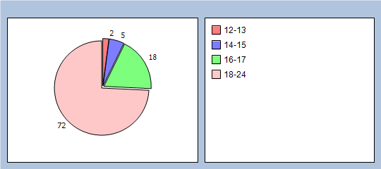  25-30 | 0
Are you?
Male | 6
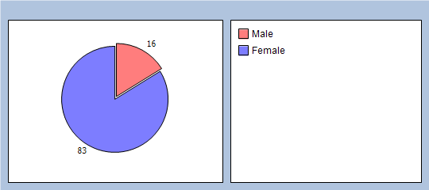  Female | 31

Section 2 - Do You Have a Disability?
If no skip to section three
Learning Disability | 0
Physical Disability | 1
Hearing Problems | 0
Vision Problems | 1
Depression | 7
Other, please state: | 0
"aspergers"
"chronic fatigue"
Section 3 - Are You a Carer?
If yes, please visit the Carers' section of the website for more information
Yes | 0
No | 37
Section 4 - Your Last Visit To The Surgery
How did you get to the surgery?
Bus | 3
Train | 0
Bicycle | 0
Walk | 14
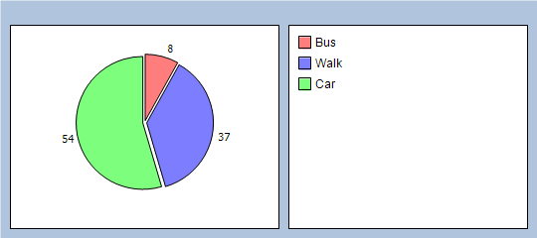  Car | 20

Did you find it easy to make your appointment?
Yes | 36
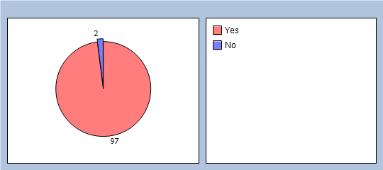  No  No | 1
Was the appointment at the right time for you?
Yes | 34
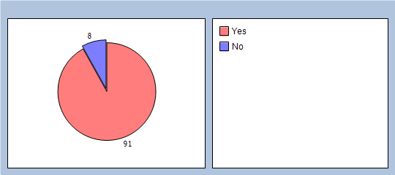  No  No | 3
Did you find the staff friendly and welcoming?
Yes | 37
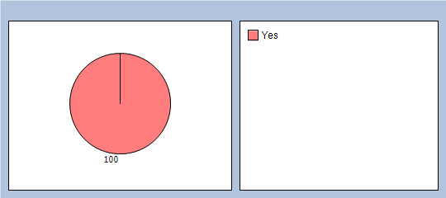  No | 0

Would you encourage your friends to use this surgery?
Yes | 37
No  No | 0
During your appointment did you feel okay to ask questions about treatment if you were not sure or didn’t understand?
Yes | 37
No  No | 0

How was your overall experience using the surgery? Rate your experience 1-5 (1 being poor and 5 being excellent)
1 | 0
2 | 0
3 | 2
4 | 13
5 | 22
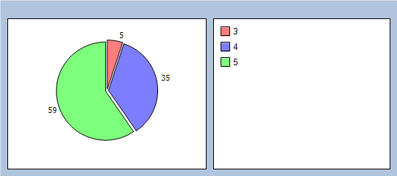

Section 5 - Feedback
Did you know we have a young people’s representative at the surgery?
Yes | 3
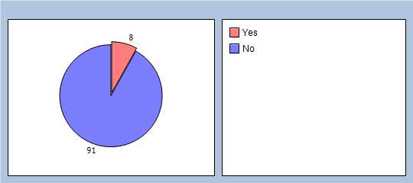  No  No | 34

Would a surgery Facebook page be something you would use or be interested in which would be just for young people?
Yes | 15
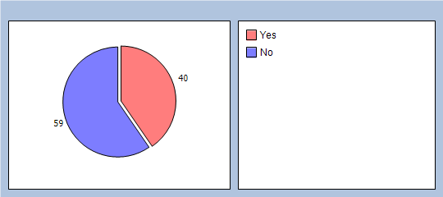  No  No | 22
Did you know the surgery had a Patient Voice email group which enables patients to let us know how we can improve services?
Yes | 3
No  No | 34
If you would like to be part of the patient voice email group, please provide your email address below:
Five e-mail addresses were provided
Are there any other comments you would like to make?
"lovely doctor Ruth Barnes"
"not always being listened to and taken seriously but only happened twice in 5 years"

